Quinn Bowers

Varsity Robotics Audition Documentation

13 March 2017

Arm that I Refuse to Name with an Epsilon

# What is this?

This is an arm. The arm has 4 joint-area-things.

The first is the hand, which for simplicity’s sake I’ll count as one. It has three fingers that open and close. These fingers can be swapped out pretty easily as long as the replacements have the right joint at the back.

Secondly there is an elbow. As the name implies, it is the joint between the forearm (which is statically attached to the hand) and the bicep.

There is a shoulder joint, which allows the bicep to move in relation to the base.

Finally, there is (or should be) a large swivel joint on the bottom of the base piece, which should allow the whole shebang to rotate.

# How does it do things?

The servos driving each of these elements all have a standing axial torque of 422 Nmm, meaning they apply 422 Newtons of force with a radius of one milimeter. The force decreases with distance. Additionally, I am not considering friction because that takes time and testing, so be aware that the actual torques and forces are less than the following.

The hand has a fingerpusher piece with a worm gear in the center. It effectively translates the rotation of the servo into linear motion, back into rotation in the fingers.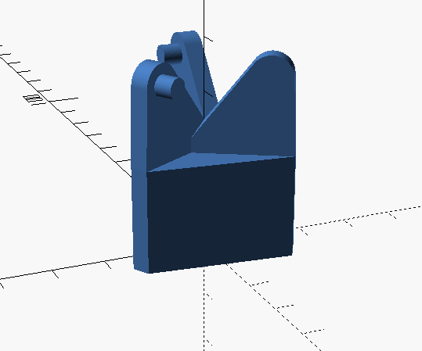 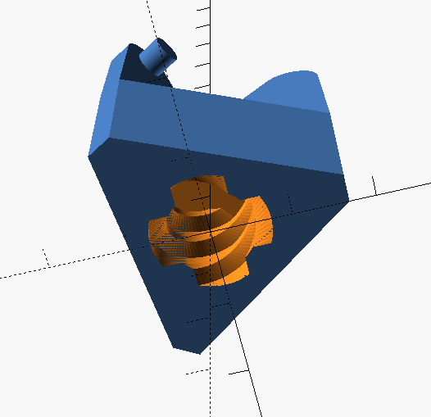 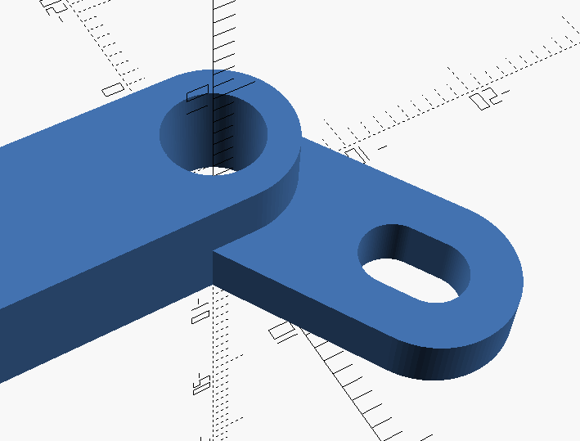

Given that the worm gear has a radius of 7.2 mm, it diverts 58.6 Newtons upwards into the fingerpusher. The fingerpusher applies that force to the three fingers at a variable radius. We’ll use the smallest radius, 12.5 mm, for simplicity’s sake. The minimum torque on an individual finger is 244.2 Nmm. The total minimum torque the hand can apply is 732.5 Nmm, although the actual force depends on the distance from the finger’s focal point.

Next are the two joints, the shoulder and the elbow. Given that the servo rotates 180 degrees, and that I want the limb itself to rotate only 90 degrees (Again, I did this for simplicity), I can come up with two equations:

These concepts are illustrated below.

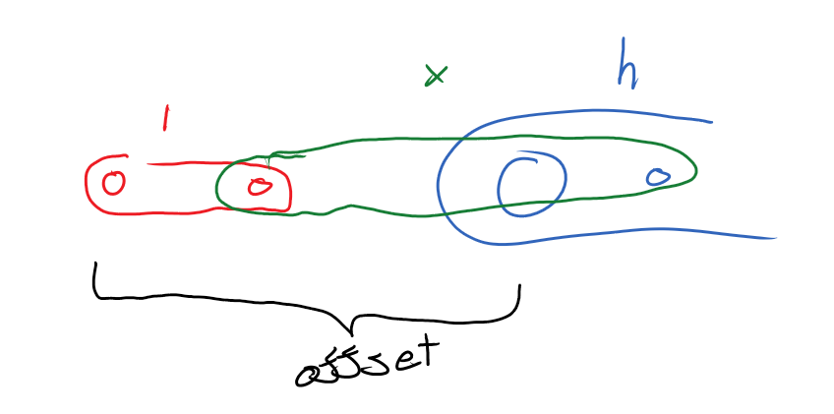 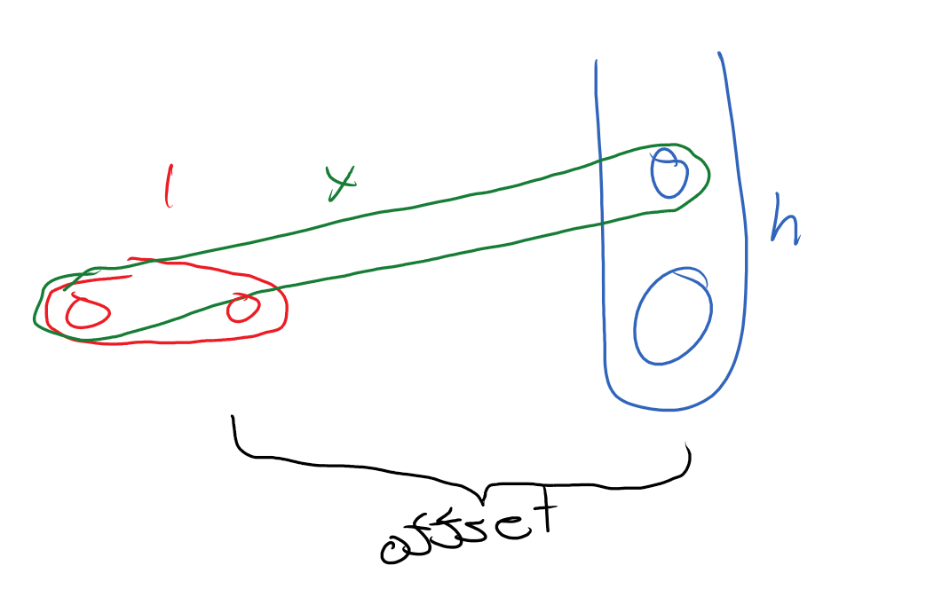

With a static servo-arm-length () and a static offset, I can determine the x and h that work for these two things. Thanks to this, each joint has exactly 90 degrees of freedom.

The one last moving part is the base of the arm. The base is divided into two sections: the top, to which the shoulder, the servos, the DC motor, and the outer guide are attached, and the bottom, which holds the bottom of a potentiometer, the inner guide, all the electronics, and is where this thing would be mounted.

As their names suggest, the outer guide fits neatly around the inner. The outerguide has housings for wheels to help it rotate nicely (though these have not been tested thanks to some machine breakdowns. This was the plan though.) and a little lip to keep it attached to the inner grid. Also some holes to screw it onto the bottom of the base top.

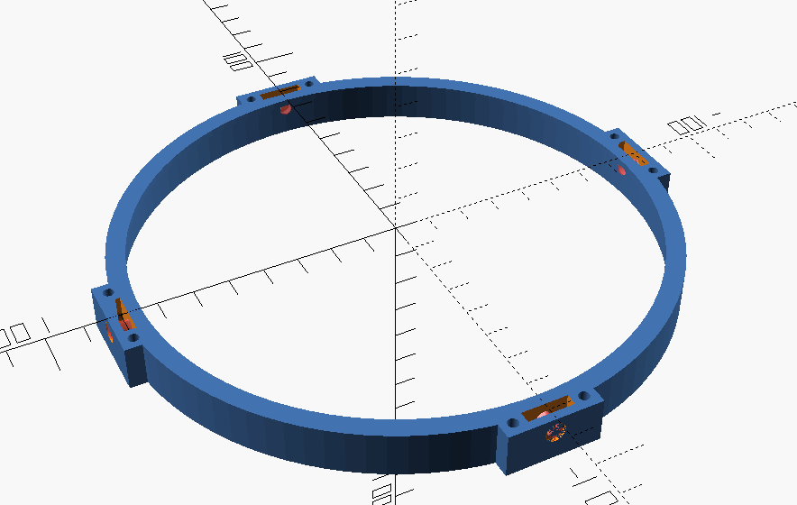 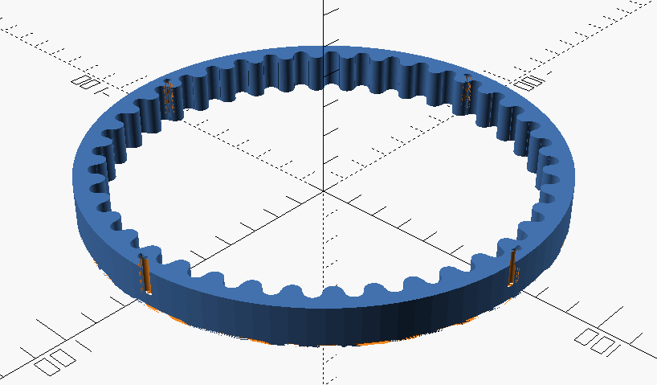

The inner guide has a few similar elements: holes for screws, a notch for the outer guide’s lip. It also has several teeth. A gear on the DC motor (which is connected to the top), can rotate along the inner guide, turning the top in relation to the bottom.

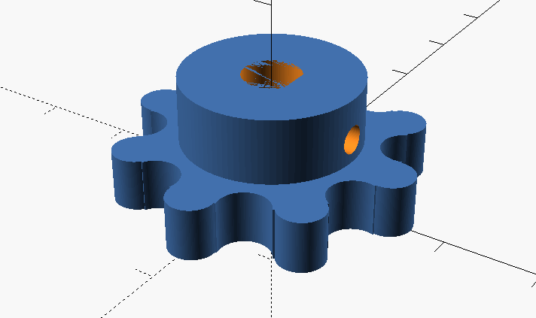 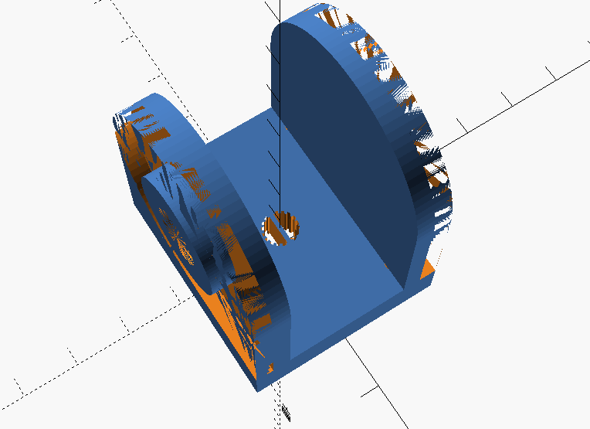

The shoulderbracket in the center has a hole for a potentiometer. The top of the potentiometer turns with the top piece, the bottom stays aligned with the bottom. This gives some measure of how far the top is turned.

The last thing I wanted to do (but didn’t because time) was cover the inside of the fingers with bits of electrostatic foam. The more electrostatic foam is compressed, the more conductive it becomes. This could be used as a sort of pressure sensor, to keep from over-tightening the fingers. The servo, being too strong, will strip the inside of the worm gear to which it is attached if that gear doesn’t move with it.

# What is it actually good for?

Nothing. The end.

This configuration of bits is basically useless, however each element could be used separately in a finished FTC robot.

The hand-grabber-thing could be used to grab particles, however that would require a high degree of precision, and so scoops would likely be much more useful. Only a more-or-less nonmoving game element could be feasibly picked up by this hand. Alternatively, the fingers could be increased in length and spread, to require less accuracy for particle consumption.

For such a static game element, like perhaps a loop you must grab and put somewhere, the complete arm might actually be useful, given that the thing can’t run away and that the claw could be easily given grippier fingers.

The swivel base would be helpful for any bot-parts we want to move separately from the rest of the robot. It was suggested that the cannon move separately from last year’s robot, and though we quickly discarded that idea, this swivel base may have been a good way to do it. Apart from that particular example, I’m not sure what else you’d want to swivel.

Any other appendage-like attachment which we may need in the future could use a design similar to this for the arms themselves. The lengths of things can be adjusted relatively easily, as will be discussed in the next section.

# How is this?

Hand Assembly:

Print three fingers, three fingerpins, a fingerpusher, a worm gear, and a hand. A servo is also required. I used micro-servos, but feasibly the parameters for the servo can be changed to fit a larger motor. Warning: doing this may require additional changes.

Anyway.

Press the lateral pins on the fingerpusher into the corresponding holes in the fingers. Then lower the whole thing into the hand piece so that the finger pusher threads are aligned like so.

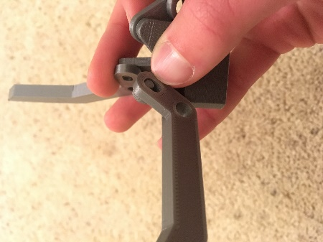 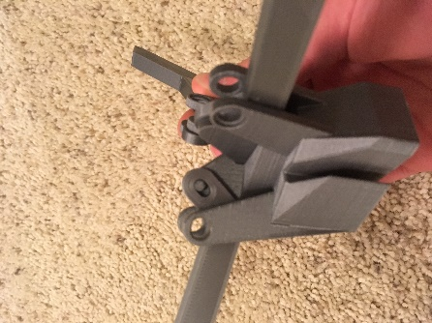 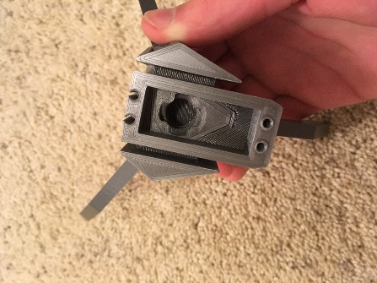 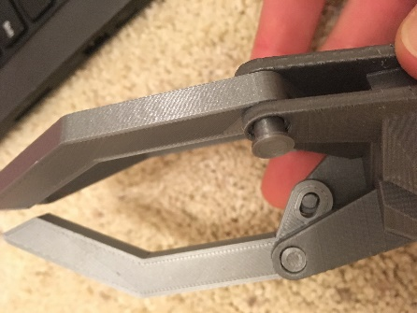

Fit the fingerpins through the holes in the hand and the holes in the fingers. The wider part of the pin goes into the correspondingly wider hole.

Remove the servo screw from the servo. Place the worm gear on the servo so that the top of the treads resembles the photo AND the servo is turned to its most counter clockwise. This is intentionally misaligned with the fingerpusher threads. Place the worm gear into the fingerpusher, and then turn the servo and the worm gear into the fingerpusher. Push the entire thing into the hand and screw it in.

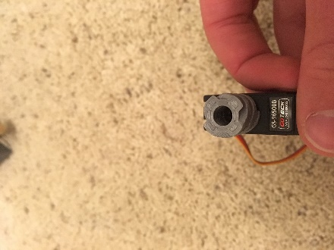 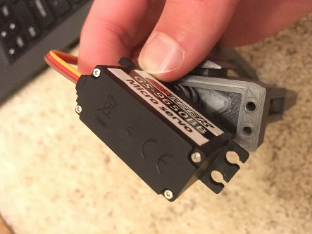 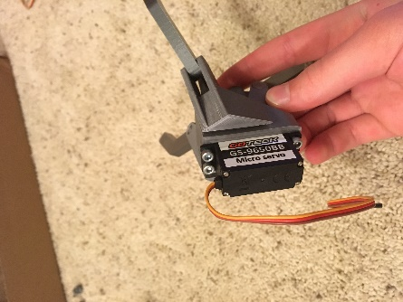

Forearm Assembly:

Cut two forearms and four appropriate crossbeams. Assemble them as in the picture. Ignore the other silver bits for the moment. Then jam the front part (the end with the square hole and the angles) into the hand.

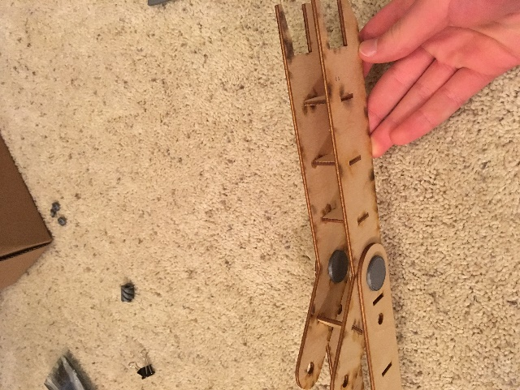 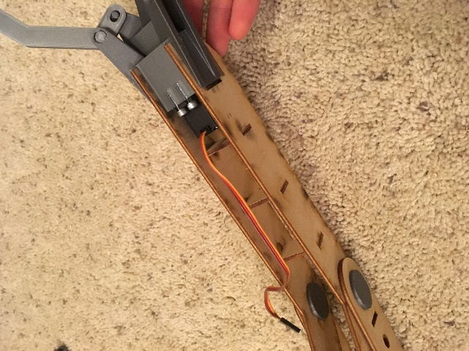

Bicep Assembly:

Cut two biceps and two appropriate crossbeams. Print four jointpintops, two jointpins, and one shoulderbracket. Place one shoulder on one of the shoulderbracket’s pins. Be sure that the small hole is far away from the shoulder. Some sanding of the pin may be required to get this to fit and rotate nicely. Place a jointpintop on the pin outside of the bicep. Fit the crossbeams into the appropriate holes. Place the other bicep onto the jointpin and the crossbeams at once. Add another jointpintop, on this side this time

Position the forearm between the two bicep pieces. Slide a jointpin through both the forearm and the bicep on either side. Put a jointpintop on the other end of the pin. Glue it on if it does not stick with friction.

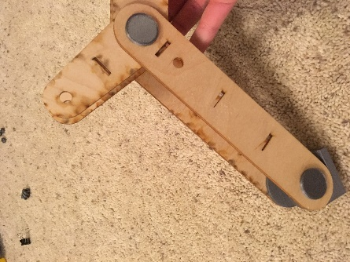 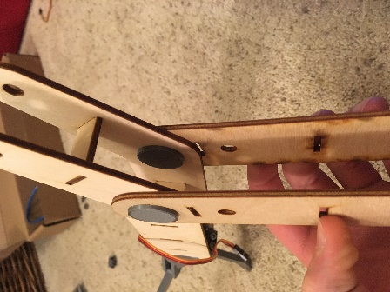

The rest of it:

I have yet to finish this part, due to machine breakdowns, but it should be assembled like so:

Screw two servos into two servobrackets (They should only fit in one way). Attach a servoarm1 to each and screw that in. Place one of the other servoarms on the pin and glue a servopintop to the top of the pin. Be sure not to glue the wood arm to any of the pieces

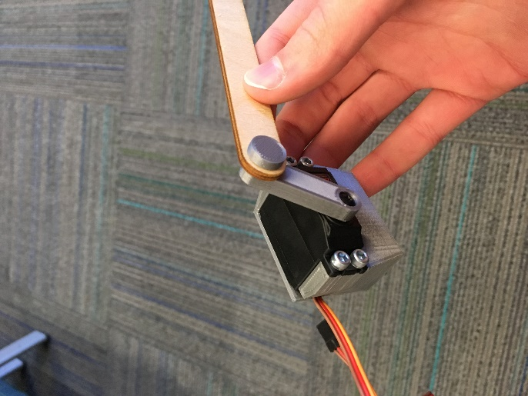 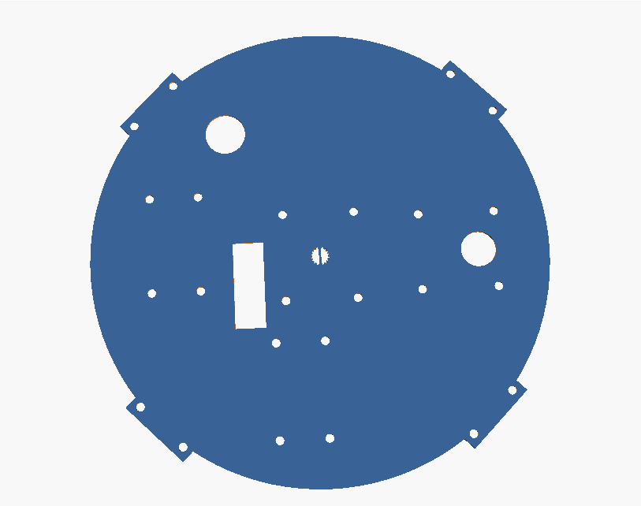

Press a DC motor into a DCmotorbracket. Screw the shoulder bracket into the four holes in the center of the flat base top piece. Ensure that the “forward” part of the bracket (the part that the bicep can turn into) is facing the section without any holes in it. If that direction is forward, screw the DCmotorbracket in to the right, so that the motor’s axel fits through the appropriate hole. Screw in the servobracket with the longer arm immediately to the left of the shoulderbracket, and the shorter one just behind it. Be sure that the nub on the servo is towards the back.

Place a servopin into the long servoarm’s far hole, and put the other end of the pin into the hole on the elbow. Glue caps on. Do the same thing with the short arm and the bicep.

Pass all the wires through the appropriate hole to the forward left.

Screw the gear onto the DCmotor below the top piece. Put the innerguide inside the outerguide and screw the outer one onto the top piece.

Put a wheel in each wheelhouse on the outerguide and stick a wheelpin through it.

Insert a potentiometer through the hole in the center. It should go through the plastic of the shoulderbracket as well. Pass all the wires (including those for the potentiometer) through another hole, but leave enough slack for the arm to rotate freely. Line the bottom of the potentiometer up with the hole in the bottom flat piece and press the bottom upwards.

Screw the innerguide onto the bottomflat. You may have to turn it to do that. The arm construction is now complete.

# How does one fix this?

If pins begin to loosen, either print another one or glue it to it holder. That may be the pintop, or just the holes in the hand or whatever. Remember not to glue it to the moving part.

If the servo makes a clicking noise when not allowed to close fully, that means the servo is slipping against the worm gear. You can try printing a tighter worm gear, or you may have to simply replace the servo. Either way, you’ll have to get at the hand. Rip it off of the forearm and unscrew the servo. Replace whichever part needs replacing, and remember to line up the worm gear correctly. Re insert the worm gear and servo as described in the construction process, screw in the servo, and reattach the hand to the forearm.

These are all the problems I have discovered.